Task 2: WGUPS Routing Program Planning

Data Structures & Algorithms 2

William Jackson
D. Provide an intuitive interface for the user to view the delivery status (including the delivery time) of any package at any time and the total mileage traveled by all trucks.

- Provide screenshots to show the status of all packages loaded onto each truck at a time between 8:35 a.m. and 9:25 a.m.

Status of all packages at 9:00 AM

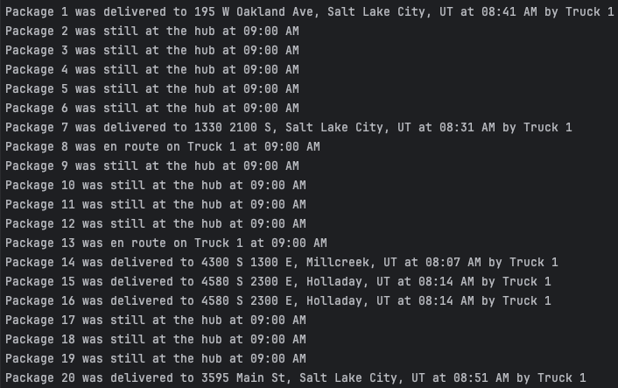
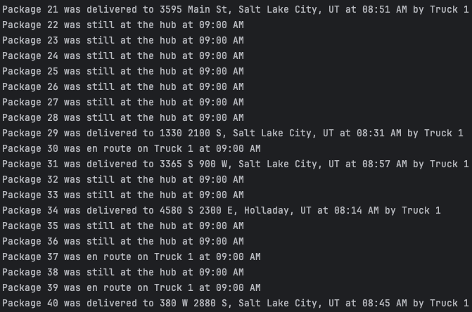
- Provide screenshots to show the status of all packages loaded onto each truck at a time between 9:35 a.m. and 10:25 a.m

Status of all packages at 10:00 AM
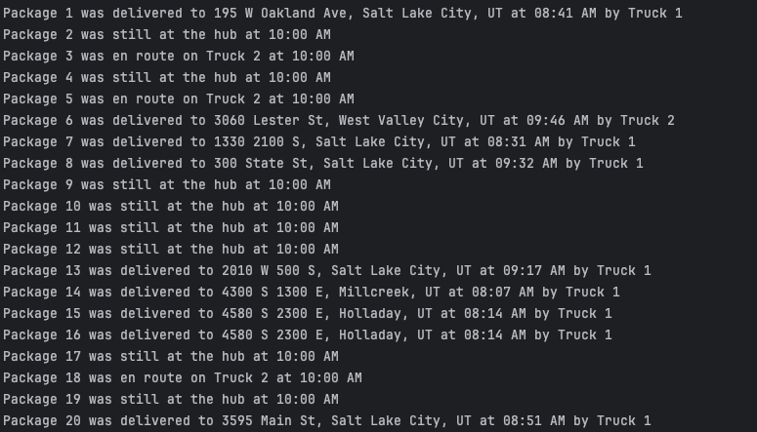
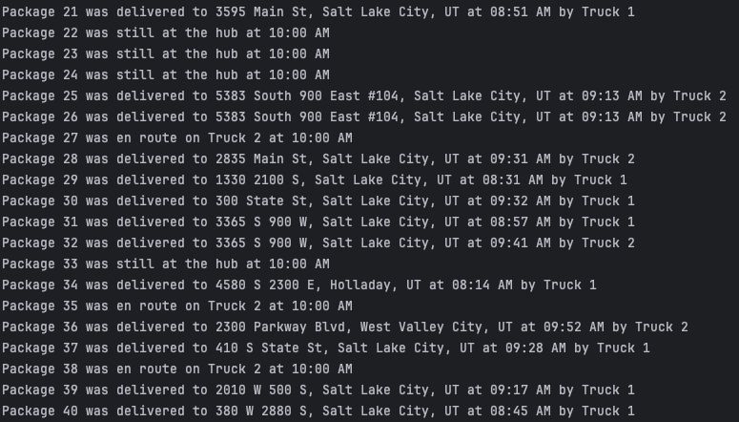
- Provide screenshots to show the status of all packages loaded onto each truck at a time between 12:03 p.m. and 1:12 p.m.
Status of all packages at 1:00 PM (all packages delivered at this time)
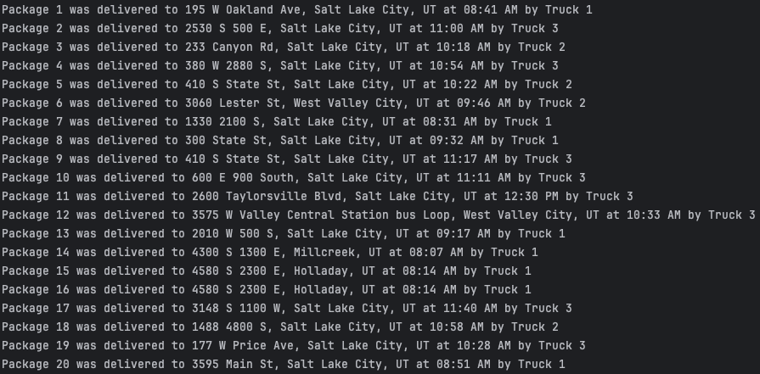
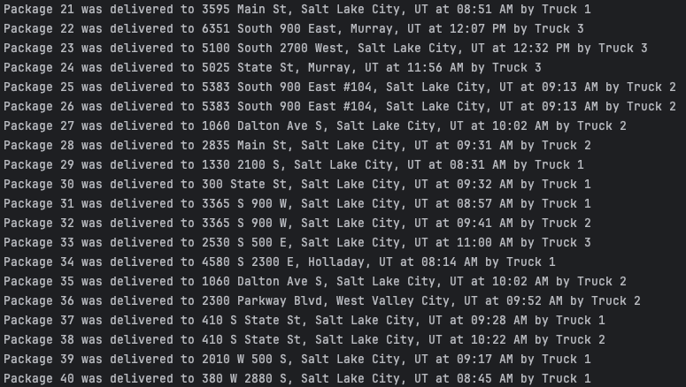

E. Provide screenshots showing successful completion of the code that includes the total mileage traveled by all trucks.
User interface when running the program

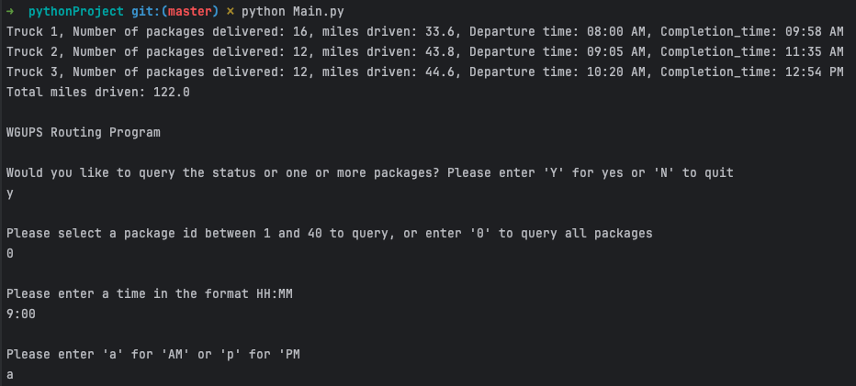

F. Justify the package delivery algorithm used in the solution as written in the original program by doing the following:
1. Describe two or more strengths of the algorithm used in the solution.
One major strength of the nearest neighbor algorithm is that it is relatively simple to understand and code and takes up limited space as it’s a nested loop of the packages list.
Another advantage is that it is easily extendable since it reorders the packages based on a specific parameter. In the solution, it reorders packages based on the smallest distance to the next package, but it could easily be modified to reorder based on the nearest approaching deadline for example.
A related advantage is that objects from different classes could be ordered together since they would only need to share the parameter that the reordering is based upon, for example, mail packages, fliers, or food delivery items could all be ordered and delivered together as long as they have an address and address id.

2. Verify that the algorithm used in the solution meets all requirements in the scenario.

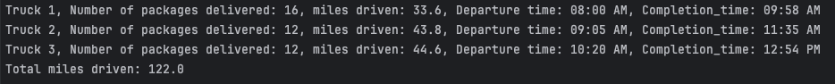

The algorithm meets all the requirements in the scenario since the total miles driven is less than 140 (122.0 was driven), all packages are delivered well before the end of the day, and an inspection of the screenshot for section D.3 reveals that all package ids with deadlines earlier than EOD were delivered before their specific deadlines. Lastly, the packages that were not ready at 8:00 AM but ready at 9:05 AM were loaded on Truck 2 and departed at 9:05 AM, while the remaining packages (including package 9 whose address was known at 10:20 AM) were loaded on Truck 3 and departed at 10:20 AM.

3. Identify two other named algorithms that are different from the algorithm implemented in the solution and would meet all requirements in the scenario.
a. Describe how both algorithms identified in part F3 are different from the algorithm used in the solution.
One alternative solution would have been to use a modified version of Dijkstra’s algorithm.
Dijkstra’s algorithm yields the shortest path tree, so for each package location, the algorithm
Could be run and then the vector (representing packages) with the smallest edge value
(representing distance in miles) from the current package could be selected as the next package
to deliver. This solution is also a nested loop and would have a similar quadratic time complexity
to the nearest neighbor, expressed as O(V^2). Dijkstra’s algorithm is different from the nearest
neighbor in that it is ideally used to map the shortest path between two locations even when the
two locations don’t connect directly, in other words, when they connect indirectly via
intermediate locations. In the scenario for this program, the shortest distance between any two
points was given so that calculating the shortest paths was unnecessary. Another difference is
that Dijkstra’s algorithm also uses a graph data structure instead of a hash table.

Another solution would be to use a brute-force algorithm. This solution would have explored all
possible permutations of package ordering, thus guaranteeing that the most optimal ordering is
found. The downside to this is that this brute force algorithm would have a time complexity of
O(N!), which is factorial time and the worst big O notation possible. This solution is ill-equipped
to scale and therefore only practical when the number of packages is limited.

G. Describe what you would do differently, other than the two algorithms identified in part F3, if you did this project again, including details of the modifications that would be made.
If I were to write this program again, I would have written an algorithm that distributes the
packages among the different trucks. As it stands, the packages are distributed manually, and
with 121 miles driven, the program meets the requirements of traveling less than 140 total miles
to deliver all packages. A more optimized package distribution, however, I believe could reduce
the driven miles to less than 100. Such a distribution algorithm would first group all packages
into address ID groups, then it would seek to load groups with early deadlines and where all
packages are ready onto the earliest trucks. Groups should never be split unless necessary due to
a deadline. The nearest neighbor algorithm would be applied to add groups with addresses close
to a group already allocated to the truck. Once all packages are distributed among the trucks, I
would still run the nearest neighbor algorithm to reorder packages within a truck to ensure
an efficient route. Apart from being more performant, this solution also frees the developer or
user from having to manually edit the package lists for each truck and instead only focus on
updating the CSV files.

H. Verify that the data structure used in the solution meets all requirements in the scenario.
1. Identify two other data structures that could meet the same requirements in the scenario.
a. Describe how each data structure identified in H1 is different from the data structure used in the solution.
The hash table used in the solution meets all requirements in the scenario. It has O(1) lookup, insertion, and removal because the hashed function and modulo calculation performed on the package ID key yields a bucket index that can be directly accessed at O(1) constant time. Only if there are collisions will there be a follow-up linear lookup, insertion, or deletion. The hash table also properly stores all information in that the package ID key can be used to retrieve the package object which is the value. The package object contains the following required components among others:
• delivery address
• delivery deadline
• delivery city
• delivery zip code
• package ID
• package weight
• delivery status

One alternative data structure is a binary search tree. Sorting the tree based on the package ID value, each package would furthermore point to a left (smaller package ID value) and right child node package (larger package ID value). Such a data structure would provide logarithmic time complexity for search, update, and deletion provided that the tree is relatively balanced. Traveling the tree entails one operation per level so the Big O notation is O(H) where H represents the height of the tree. Since the height of the tree is a base two logarithmic function of the number of nodes, the time complexity can also be expressed as O(logN). This is less performant than the constant time operations for a hash table.

Another data structure option would be to apply a singly or doubly linked list. A linked list has each node pointing to the next node in the list, and the previous node if it is doubly linked. The advantage of the linked list is relative memory efficiency since the objects can be scattered in memory, no surplus memory needs to be allocated, and the list never needs to be resized. These are all advantages over dynamic arrays as used in the hash table which allocate several contiguous memory locations upon creation. The drawback of linked lists is slow operations. The linked list needs to be traversed starting at the head to lookup, insert, or delete a node which yields linear, O(N) time complexity.

